BATCH AND ROLL NO:
EXPERIMENT NO.: 03
TITLE: Design a mobile application to create the login page using sqlite /firebase
DATE OF PERFORMANCE:
DATE OF CHECKING:

Title: Design a mobile application to create the login page using sqlite /firebase

Requirements:
1 Android studio
- Sqlite /firebase
Theory:
In software applications, it is mostly required to store users and app data locally. Android SDK provides several APIs for developers to save user and app data, So SQLite is one of the ways of storing data. For many applications, SQLite is the backbone of the app whether it’s used directly or via some third-party wrapper. SQLite is a lightweight database that comes with android. It is an Open-Source embedded SQL database engine. This provides a relational database management structure for storing user-defined records in the form of tables.

Here are the general steps to create login page using SQLite in Android Studio:

  - Create a Home Screen JAVA Activity, Which will hold ‘Sign In‘and ‘Sign Up‘options.
  - Create XML layouts for home screen and ‘Sign In‘and ‘Sign Up‘Screens.
  - Create a SQLite Database in the application’s context, so that we can save all required user data (‘Sign In‘and ‘Sign Up‘details).
  - Code Logic in Application’s Java files.
  - Run Android Login Registration app on Device/Emulator.

Code:
JAVA Codes
- DBHelper.java
package com.example.loginsqliteapp;

import android.content.ContentValues;
import android.content.Context;
import android.database.Cursor;
import android.database.sqlite.SQLiteDatabase;
import android.database.sqlite.SQLiteOpenHelper;

public class DBHelper extends SQLiteOpenHelper {

public static final String DBNAME = "Login.db";

public DBHelper(Context context) {
super(context, DBNAME, null, 1);
}

@Override
public void onCreate(SQLiteDatabase db) {
db.execSQL("CREATE TABLE users(username TEXT PRIMARY KEY, password TEXT)");
}

@Override
public void onUpgrade(SQLiteDatabase db, int oldVersion, int newVersion) {
db.execSQL("DROP TABLE IF EXISTS users");
onCreate(db);
}

public Boolean insertData(String username, String password) {
SQLiteDatabase db = this.getWritableDatabase();
ContentValues values = new ContentValues();
values.put("username", username);
values.put("password", password);
long result = db.insert("users", null, values);
return result != -1;
}

public Boolean checkusername(String username) {
SQLiteDatabase db = this.getReadableDatabase();
Cursor cursor = db.rawQuery(
"SELECT * FROM users WHERE username=?",
new String[]{username}
);
boolean exists = cursor.getCount() > 0;
cursor.close();
return exists;
}
public Boolean checkusernamepassword(String username, String password) {
SQLiteDatabase db = this.getReadableDatabase();
Cursor cursor = db.rawQuery(
"SELECT * FROM users WHERE username=? AND password=?",
new String[]{username, password}
);
boolean exists = cursor.getCount() > 0;
cursor.close();
return exists;
}}

- MainActivity.java
package com.example.loginsqliteapp;

import android.content.Intent;
import android.os.Bundle;
import android.widget.*;
import androidx.appcompat.app.AppCompatActivity;

public class MainActivity extends AppCompatActivity {

EditText username, password, repassword;
Button signup, signin;
DBHelper DB;

@Override
protected void onCreate(Bundle savedInstanceState) {
super.onCreate(savedInstanceState);
setContentView(R.layout.activity_signup);

username = findViewById(R.id.username);
password = findViewById(R.id.password);
repassword = findViewById(R.id.repassword);
signup = findViewById(R.id.btnsignup);
signin = findViewById(R.id.btnsignin);

DB = new DBHelper(this);

signup.setOnClickListener(v -> {

String user = username.getText().toString();
String pass = password.getText().toString();
String repass = repassword.getText().toString();

if (user.isEmpty() || pass.isEmpty() || repass.isEmpty()) {
Toast.makeText(this, "Fill all fields", Toast.LENGTH_SHORT).show();
return;
}

if (!pass.equals(repass)) {
Toast.makeText(this, "Passwords not matching",

Toast.LENGTH_SHORT).show();
return;
}

if (DB.checkusername(user)) {
Toast.makeText(this, "User already exists", Toast.LENGTH_SHORT).show();
return;
}

if (DB.insertData(user, pass)) {
Toast.makeText(this, "Registered Successfully", Toast.LENGTH_SHORT).show();
startActivity(new Intent(this, LoginActivity.class));
finish();
}
});

signin.setOnClickListener(v ->
startActivity(new Intent(this, LoginActivity.class)));
}
}

- LoginActivity.java
package com.example.loginsqliteapp;

import android.content.Intent;
import android.os.Bundle;
import android.widget.*;
import androidx.appcompat.app.AppCompatActivity;

public class LoginActivity extends AppCompatActivity {

EditText username, password;
Button login;
DBHelper DB;

@Override
protected void onCreate(Bundle savedInstanceState) {
super.onCreate(savedInstanceState);
setContentView(R.layout.activity_login);

username = findViewById(R.id.Username1);
password = findViewById(R.id.Password1);
login = findViewById(R.id.btnLogin1);

DB = new DBHelper(this);

login.setOnClickListener(v -> {

String user = username.getText().toString();
String pass = password.getText().toString();

if (user.isEmpty() || pass.isEmpty()) {
Toast.makeText(this, "Fill all fields", Toast.LENGTH_SHORT).show();
return;
}

if (DB.checkusernamepassword(user, pass)) {
Toast.makeText(this, "Login Success", Toast.LENGTH_SHORT).show();
startActivity(new Intent(this, HomeActivity.class));
finish();
} else {
Toast.makeText(this, "Invalid Credentials", Toast.LENGTH_SHORT).show();
}
});
}
}

- HomeActivity.java
package com.example.loginsqliteapp;
import android.os.Bundle;
import androidx.appcompat.app.AppCompatActivity;
public class HomeActivity extends AppCompatActivity {
@Override
protected void onCreate(Bundle savedInstanceState) {
super.onCreate(savedInstanceState);
setContentView(R.layout.activity_home);
}
}

XML Codes
- activity_main.xml
<?xml version="1.0" encoding="utf-8"?>
<RelativeLayout xmlns:android="http://schemas.android.com/apk/res/android"
android:padding="20dp"
android:layout_width="match_parent"
android:layout_height="match_parent">

<EditText
android:id="@+id/username"
android:layout_width="match_parent"
android:layout_height="wrap_content"
android:layout_marginTop="60dp"
android:hint="Username" />

<EditText
android:id="@+id/password"
android:layout_width="match_parent"
android:layout_height="wrap_content"
android:layout_below="@id/username"
android:layout_marginTop="45dp"
android:hint="Password"
android:inputType="textPassword" />

<EditText
android:id="@+id/repassword"
android:layout_width="match_parent"
android:layout_height="wrap_content"
android:layout_below="@id/password"
android:layout_marginTop="45dp"
android:hint="Retype Password"
android:inputType="textPassword" />

<Button
android:id="@+id/btnsignup"
android:layout_width="match_parent"
android:layout_height="wrap_content"
android:layout_below="@id/repassword"
android:layout_marginTop="58dp"
android:text="Register" />

<Button
android:id="@+id/btnsignin"
android:layout_width="match_parent"
android:layout_height="wrap_content"
android:layout_below="@id/btnsignup"
android:layout_marginTop="29dp"
android:text="Already user? Login" />

<TextView
android:id="@+id/textView"
android:layout_width="wrap_content"
android:layout_height="wrap_content"
android:text="Roll No - 42308" />

</RelativeLayout>

- activity_login.xml
<?xml version="1.0" encoding="utf-8"?>
<LinearLayout xmlns:android="http://schemas.android.com/apk/res/android"
android:layout_width="match_parent"
android:layout_height="match_parent"
android:orientation="vertical"
android:padding="24dp"
android:gravity="center">

<TextView
android:text="Login Form"
android:textSize="26dp"
android:textColor="@android:color/holo_purple"
android:layout_marginBottom="20dp"
android:layout_width="wrap_content"
android:layout_height="wrap_content"/>

<EditText
android:id="@+id/Username1"
android:layout_width="match_parent"
android:layout_height="wrap_content"
android:hint="Username"/>

<EditText
android:id="@+id/Password1"
android:layout_width="match_parent"
android:layout_height="wrap_content"
android:hint="Password"
android:inputType="textPassword"
android:layout_marginTop="16dp"/>

<Button
android:id="@+id/btnLogin1"
android:layout_width="match_parent"
android:layout_height="wrap_content"
android:text="LOGIN"
android:layout_marginTop="20dp"/>

</LinearLayout>

- activity_home.xml

<?xml version="1.0" encoding="utf-8"?>
<LinearLayout xmlns:android="http://schemas.android.com/apk/res/android"
android:layout_width="match_parent"
android:layout_height="match_parent"
android:gravity="center"
android:orientation="vertical">

<TextView
android:text="Login Successful!!"
android:textSize="26dp"
android:textColor="@android:color/holo_purple"
android:layout_width="wrap_content"
android:layout_height="wrap_content"/>
</LinearLayout>

Output:

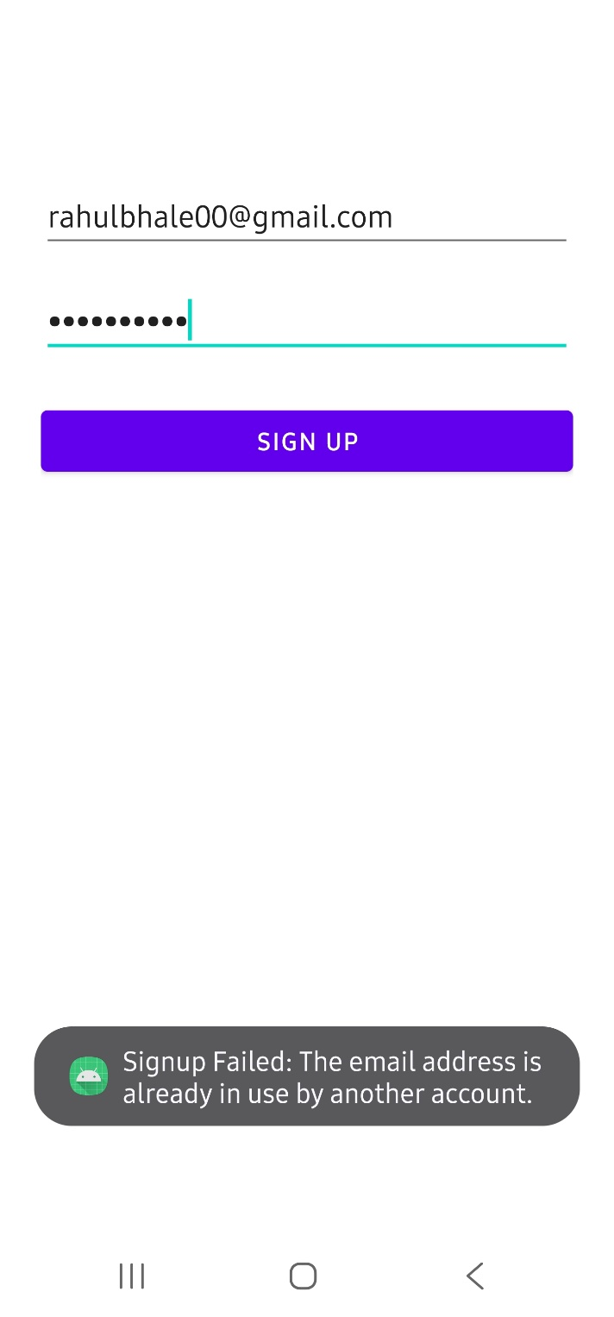 | 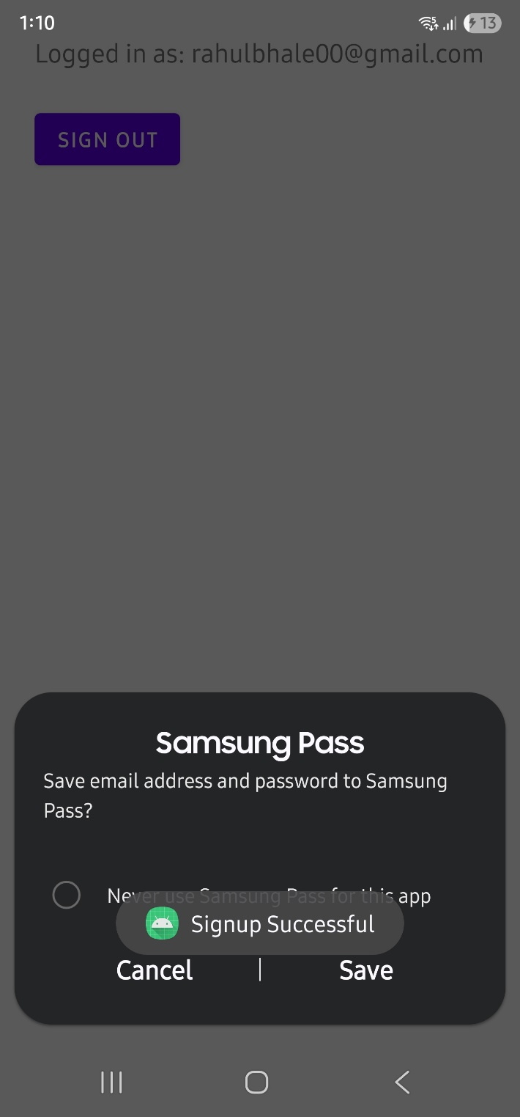
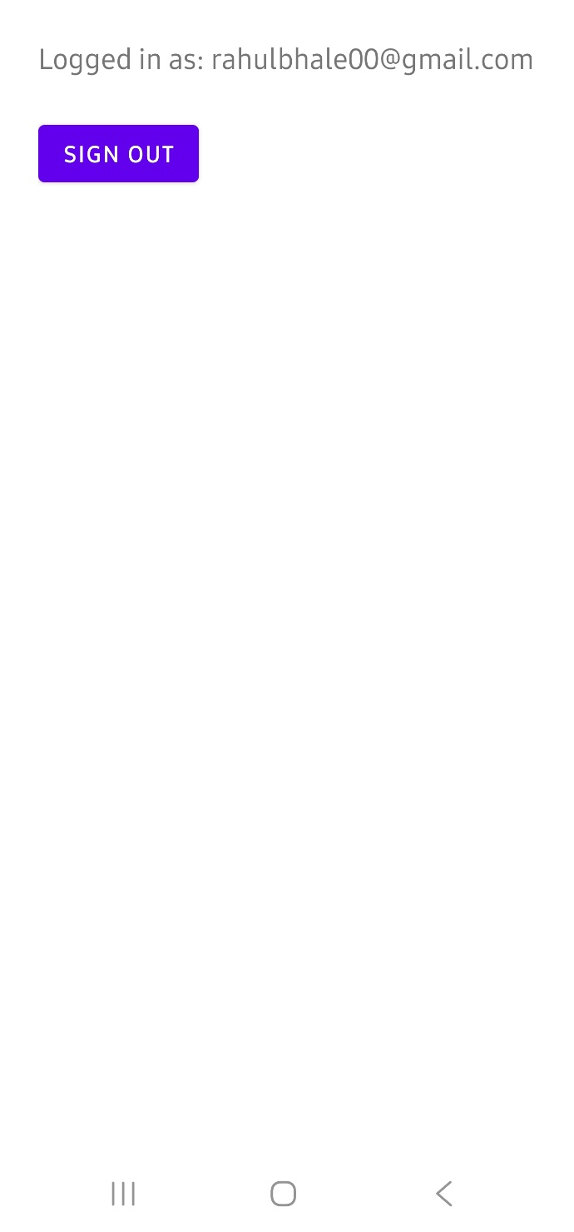 | 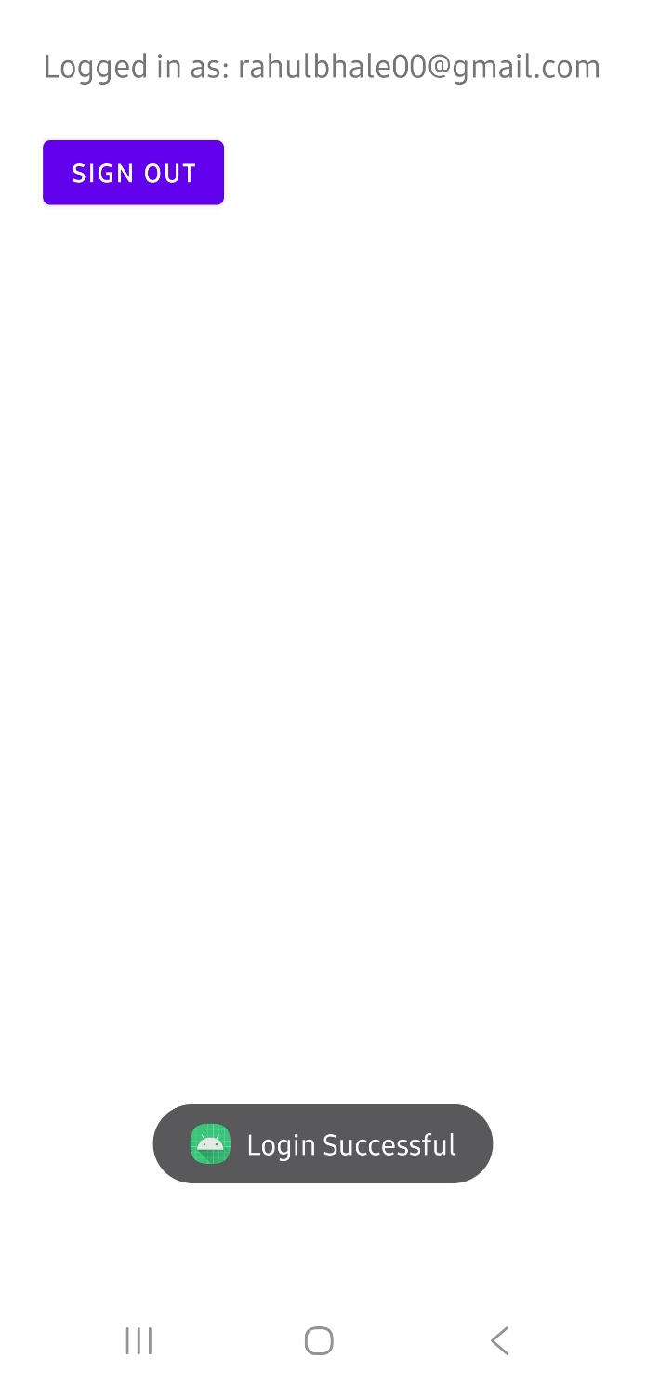

CONCLUSION:

……………………………………………………………………………………………

……………………………………………………………………………………………

……………………………………………………………………………………………

